Participation Assignment: Group 7, E 10, Part I, Of Miracles

Sophie Parish, Lola Willcock, Sophie Rowlands

Sophie Rowlands: Paragraphs E 10.1, SBN 109 - E 10.4, SBN 110-1

Sophie Parish: E 10.5, SBN 111-2 - E 10.8, SBN 113

Lola Willcock: E 10.9, SBN 113 - E 10.13, SBN 115-6

Each Group Member Provided One Mind Map and Glossary Terms for their Assigned Section

Section X

Of Miracles Part 1

E 10.1, SBN 110

THERE is, in Dr. Tillotson's writings, an argument against the **real presence**[1], which is as concise, and elegant, and strong as any argument can possibly be supposed against a doctrine, so little worthy of a serious refutation. It is acknowledged on all hands, says that learned prelate, that the authority, either of the scripture or of tradition, is founded merely in the testimony of the apostles, who were eyewitnesses to those miracles of our Saviour, by which he proved his divine mission. Our evidence, then, for the truth of the Christian religion is less than the evidence for the truth of our senses; because, even in the first authors of our religion, it was no greater; and it is evident it must diminish in passing from them to their disciples; nor can any one rest such confidence in their testimony, as in the immediate object of his senses. But a weaker evidence can never destroy a stronger; and therefore, were the doctrine of the real presence ever so clearly revealed in scripture, it were directly contrary to the rules of just reasoning to give our assent to it. It contradicts sense, though both the scripture and tradition, on which it is supposed to be built, carry not such evidence with them as sense; when they are considered merely as external evidences, and are not brought home to every one's breast, by the immediate operation of the Holy Spirit.

E 10.2, SBN 110

Nothing is so convenient as a decisive argument of this kind, which must at least silence the most arrogant bigotry and superstition, and free us from their impertinent solicitations. I flatter myself, that I have discovered an argument of a like nature, which, if just, will, with the wise and learned, be an everlasting check to all kinds of superstitious delusion, and consequently, will be useful as long as the world endures. For so long, I presume, will the accounts of **miracles[2]** and prodigies be found in all history, sacred and profane.

E 10.3, SBN 110

Though experience be our only guide in reasoning concerning matters of fact[3]; it must be acknowledged, that this guide is not altogether infallible, but in some cases is apt to lead us into errors. One, who in our climate, should expect better weather in any week of June than in one of December, would reason justly, and conformably to experience; but it is certain, that he may happen, in the event, to find himself mistaken. However, we may observe, that, in such a case, he would have no cause to complain of experience; because it commonly informs us beforehand of the uncertainty, by that contrariety of events, which we may learn from a diligent observation. All effects follow not with like certainty from their supposed causes. Some events are found, in all countries and all ages, to have been constantly conjoined together: Others are found to have been more variable, and sometimes to disappoint our expectations; so that, in our reasonings concerning matter of fact, there are all imaginable degrees of assurance, from the highest certainty to the lowest species of **moral evidence[4].**

E 10.4, SBN 110-1

**A wise man, therefore, proportions his belief to the evidence.** In such conclusions as are founded on an infallible experience, he expects the event with the last degree of assurance and regards his past experience as a full proof of the future existence of that event. In other cases, he proceeds with more caution: He weighs the opposite experiments: He considers which side is supported by the greater number of experiments: To that side he inclines, with doubt and hesitation; and when at last he fixes his judgment, the evidence exceeds not what we properly call probability. All probability, then, supposes an opposition of experiments and observations, where the one side is found to overbalance the other, and to produce a degree of evidence, proportioned to the superiority. A hundred instances or experiments on one side, and fifty on another, afford a doubtful expectation of any event; though a hundred uniform experiments, with only one that is contradictory, reasonably beget a pretty strong degree of assurance. In all cases, we must balance the opposite experiments, where they are opposite, and deduct the smaller number from the greater, in order to know the exact force of the superior evidence.

**MIND MAP, PARAGRAPH E 10.4, SBN 110-1**

“A wise man, therefore, proportions his belief to the evidence.” – bases his beliefs on the evidence that is presented to him.

In some cases; s/he will use past evidence as ‘full proof’ assurance of future events

In other cases; s/he will be more cautious to use past experience as assurance of future events

S/he will consider opposing evidence to a certain experience and base their belief on the side that has the most evidence to support it.

S/he will support that side with caution and hesitation. He will then be certain in his judgment when the evidence supporting his side “exceeds probability.”

Probability then, is the consideration of two opposing sides and the acknowledgment that one side overbalances the other side to a certain degree.

E 10.5, SBN 111-2

To apply these principles to a particular instance; we may observe, that there is no species of reasoning more common, more useful, and even necessary to human life, than that which is derived from the testimony of men, and the reports of eye-witnesses and spectators. This species of reasoning, perhaps, one may deny to be founded on **the relation of cause and effect[5]**. I shall not dispute about a word. It will be sufficient to observe, that our assurance in any argument of this kind is derived from no other principle than our observation of the veracity of human testimony, and of the usual conformity of facts to the reports of witnesses. It being a **general maxim[6]**, that no objects have any discoverable connexion together, and that all the inferences, which we can draw from one to another, are founded merely on our experience of their constant and regular conjunction; it is evident, that we ought not to make an exception to this maxim in favour of human testimony, whose connexion with any event seems, in itself, as little necessary as any other. Were not the memory tenacious to a certain degree; had not men commonly an inclination to truth and a **principle of probity**[7]; were they not sensible to shame, when detected in a falsehood: Were not these, I say, **discovered by experience[8]** to be qualities, inherent in human nature, we should never repose the least confidence in human testimony. A man delirious, or noted for falsehood and villany, has no manner of authority with us.

E 10.6, SBN 112

And as the evidence, derived from witnesses and human testimony, is founded on past experience, so it varies with the experience, and is regarded either as a **proof or a probability[9]**, according as the conjunction between any particular kind of report and any kind of object has been found to be constant or variable. There are a number of circumstances to be taken into consideration in all judgments of this kind; and the ultimate standard, by which we determine all disputes, that may arise concerning them, is always derived from experience and observation. Where this experience is not entirely uniform on any side, it is attended with an unavoidable contrariety in our judgments, and with the same opposition and **mutual destruction of argument[10]** as in every other kind of evidence. We frequently hesitate concerning the reports of others. We balance the opposite circumstances, which cause any doubt or uncertainty; and when we discover a superiority on any side, we incline to it; but still with a diminution of assurance, in proportion to the force of its antagonist.

E 10.7, SBN 112-3

This contrariety of evidence, in the present case, may be derived from several different causes; from the opposition of contrary testimony; from the character or number of the witnesses; from the manner of their delivering their testimony; or from the union of all these circumstances. We entertain a suspicion concerning any matter of fact, when the witnesses contradict each other; when they are but few, or of a doubtful character; when they have an interest in what they affirm; when they deliver their testimony with hesitation, or on the contrary, with too violent asseverations. There are many other particulars of the same kind, which may diminish or destroy the force of any argument, derived from human testimony.

E 10.8, SBN 113

Suppose, for instance, that the fact, which the testimony endeavours to establish, partakes of the extraordinary and the marvellous; in that case, the evidence, resulting from the testimony, admits of a diminution, greater or less, in proportion as the fact is more or less unusual. The reason, why we place any credit in witnesses and historians, is not derived from any connexion, which we perceive **à priori[11]**, between testimony and reality, but because we are accustomed to find a conformity between them. But when the fact attested is such a one as has seldom fallen under our observation, here is a contest of two opposite experiences; of which the one destroys the other, as far as its force goes, and the superior can only operate on the mind by the force, which remains. The very same principle of experience, which gives us a certain degree of assurance in the testimony of witnesses, gives us also, in this case, another degree of assurance against the fact, which they endeavour to establish; from which contradiction there necessarily arises a counterpoize, and mutual destruction of belief and authority.

**MIND MAP, PARAGRAPH E10.6, SBN 112**

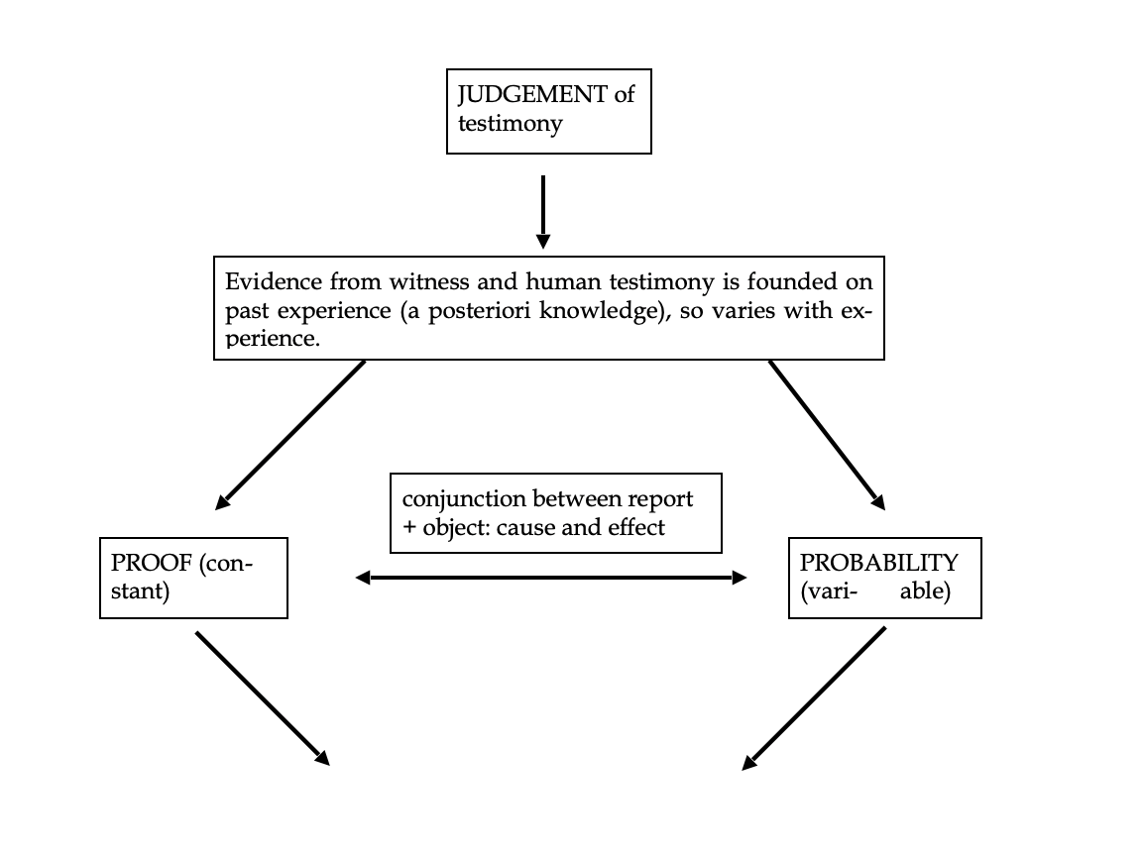

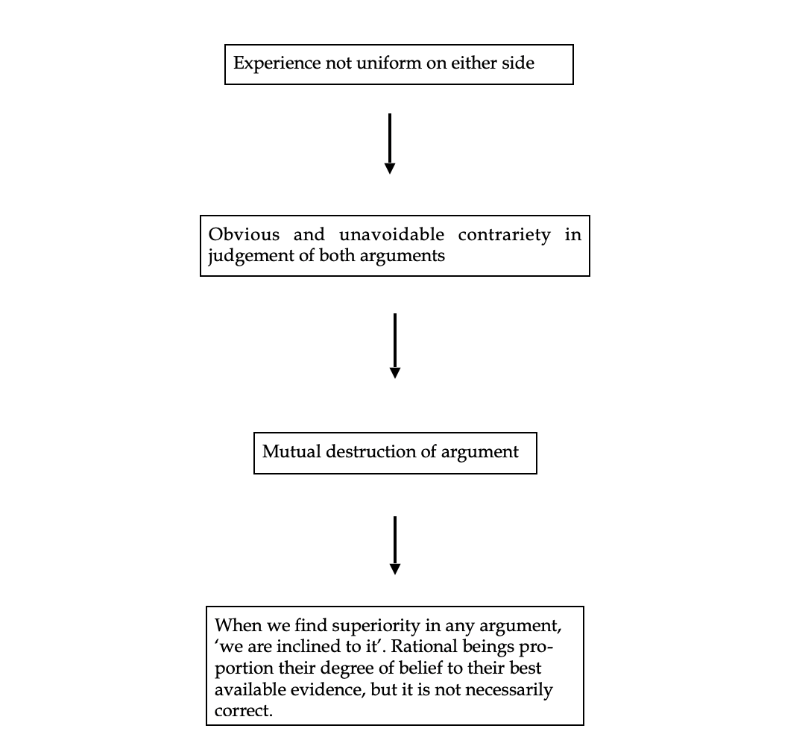

E 10.9, SBN 113

I should not believe such a story were it told me by **[12]Cato**;* was a proverbial saying in Rome, even during the lifetime of that philosophical patriot 21. The incredibility of a fact, it was allowed, might invalidate so great an authority.

E 10.10, SBN 113-4

[13]**The Indian prince**,* who refused to believe the first relations concerning the effects of frost, reasoned justly; and it naturally required very strong testimony to engage his assent to facts, that arose from a state of nature, with which he was unacquainted, and which bore so little analogy to those events, of which he had had constant and uniform experience. Though they were not contrary to his experience, they were not conformable to it 22.

E 10.11, SBN 114

But in order to encrease the probability against the testimony of witnesses, let us suppose, that the fact, which they affirm, instead of being only marvellous, is really miraculous; and suppose also, that the testimony, considered apart and in itself, amounts to an entire proof; in that case, there is proof against proof, of which the strongest must prevail, but still with a diminution of its force, in proportion to that of its antagonist.

E 10.12, SBN 114-5

A miracle is a **[14]violation of the laws of nature**;* and **[15]as a firm and unalterable experience has established these laws**, the proof against a miracle, from the very nature of the fact, is as entire as any argument from experience can possibly be imagined. Why is it more than probable, that all men must die; that lead cannot, of itself, remain suspended in the air; that fire consumes wood, and is extinguished by water; unless it be, that these events are found agreeable to the laws of nature, and there is required a violation of these laws, or in other words, a miracle to prevent them? Nothing is esteemed a miracle, if it ever happen in the common course of nature. It is no miracle that a man, seemingly in good health, should die on a sudden: because such a kind of death, though more unusual than any other, has yet been frequently observed to happen. But it is a miracle, that a dead man should come to life; because that has never been observed, in any age or country. There must, therefore, be a uniform experience against every miraculous event, otherwise the event would not merit that appellation. And as an uniform experience amounts to a proof, there is here a direct and full proof, from the nature of the fact, against the existence of any miracle; nor can such a proof be destroyed, or the miracle rendered credible, but by an opposite proof, which is superior.

E 10.13, SBN 115-6

The plain consequence is (and it is a general maxim worthy of our attention), “That no testimony is sufficient to establish a miracle, unless the testimony be of such a kind, that its falsehood would be more miraculous, than the fact, which it endeavours to establish: And even in that case there is a mutual destruction of arguments, and the superior only gives us an assurance suitable to that degree of force, which remains, after deducting the inferior.”* When any one tells me, that he saw a dead man restored to life, I immediately consider with myself, whether it be more probable, that this person should either deceive or be deceived, or that the fact, which he relates, should really have happened. I weigh the one miracle against the other; and according to the superiority, which I discover, I pronounce my decision, and always reject the greater miracle. If the falsehood of his testimony would be more miraculous, than the event which he relates; then, and not till then, can he pretend to command my belief or opinion.

**MIND MAP, E10.12, SBN 114-15**

Miracles are not real

Miracles are “a violation of the laws of nature”

A uniform experience amounts to a proof

These laws are established by “a firm and unalterable experience” – they occur in agreement

There is a uniform experience against every miraculous event

Key arguments:

* Link between ‘firm and unalterable experiences and ‘laws of nature’ is so strong that events violating such experiences must violate nature’s laws and be miracles (they occur in agreement) (E10.12)
* The only way you can have enough evidence for the miracle really happening is if the possibility of it not happening is even more crazy than the possibility that it did (E10.13)
* Even in that case, there is a mutual destruction of arguments, so the balance of evidence is always going to come down on the side of the miracle not being real (E10.13)

USEFUL SOURCES:

* Hume on Miracles: Interpretation and Criticism James E. Taylor* Westmont College
* Miracles – Internet Encyclopaedia of Philosophy
* David Hume, [An Enquiry Concerning Human Understanding](https://infidels.org/library/historical/david_hume/human_understanding.html) (1748), Ch. 10, para. 13.
* John Earman, Hume's Abject Failure: The Argument Against Miracles (New York, NY: Oxford University Press, 2000), p. 41.
* Stanford Encyclopedia of Philosophy ([https://plato.stanford.edu/entries/hume/#Cau](https://plato.stanford.edu/entries/hume/%23Cau))
* Link to read more about significance of ‘The Indian Prince’:

[https://www.jstor.org/stable/pdf/40238001.pdf?refreqid=excelsior%3A911f1408c470e423592321499c9b9aed](https://www.jstor.org/stable/pdf/40238001.pdf?refreqid=excelsior%25253A911f1408c470e423592321499c9b9aed)

1. **Real Presence** = real presence is the belief that Christ is really present in the Eucharist, not metaphorically or symbolically. The form that Christ takes is dependent on what branch of Christianity you identify with. For example, Catholics believe that Christ is actually present in physical form (body bones blood etc.)
2. **Miracles** = by definition, Hume believes that miracles are an act of God which breaks the laws of physics/nature. Hume posits the idea that it is not viable to base any truth of a religious system (Christianity) on the existence of miracles. Hume theorises that we cannot trust a testimony of a miracle because the likelihood that the testimony is false is significantly higher than the actuality of a miracle. Furthermore, Hume suggests that in no case is it rational to believe that a miracle has taken place.
3. **Matters of Fact =.** Matter of Fact, according to Hume, are when the contrary to that fact is conceivable. For example; if I drop a pen it will most likely fall because of gravity. However, it is perfectly conceivable that when I drop a pen it could just stay floating around my hand. Essentially, Matters of Fact are where the contrary to that fact is conceivable. Matter of Fact are ‘a posteriori; facts, meaning that they are revealed to us through our empirical senses. In relation to Miracles; MOF can be split into two categories. 1; Observed MOF, certain people are informing you that a certain miracle has occurred. 2; Unobserved MOF, knowing that a certain miracle has occurred. Hume suggests a conjunction between 1 & 2 the only way you are to know a miracle has occurred is by someone else’s testimony. Your belief in a miracle based on a certain person’s testimony is involving MOF reasoning from 1 to 2.
4. **Moral Evidence =** is intentional and a posteriori; it is not observed but inferred by empirical observation.
5. Hume defines the relation between cause and effect as the discovery of relations between objects of comparison, which he sees as pivotal in reasoning to understand knowledge beyond ‘immediate impressions’. He sees their relationship as a constant conjunction. In his eyes, we can understand matters of fact according to causation, so an experience of one event could bring us about a previously unobserved cause. Assumptions between cause and effect are not necessarily true or real, and they stems from knowledge by experience. 
6. Here the maxim (the general rule of law Hume abides by) mentioned concerns the credibility of miracles. According to Hume, the maxim dictates that even with the strongest testimony, the evidence for the laws of nature that have supposedly been violated, will always outweigh this. On this, Earman reduces Humes argument to the following: no one should believe a miracle unless it is greater than 50% probable in light of the evidence.
7. The principle of probity refers to integrity and honesty, ethical behaviour that encourages transparency and accountability.

  
8. This refers to a posteriori knowledge. A posteriori knowledge is knowledge acquired from experience and observation rather than a general principle (a priori knowledge). Hume notes this as a synthetic statement and one that is contingent, since it relies on the world’s state.
9. Again, here he is referring to contingent, synthetic statements which can pose the problem of induction - we can never deduce the outcome or conformity of unexamined cases, as they are based solely from experience. Hume defines a proof as a uniform experience, and a probability is“founded on the presumption of a resemblance betwixt those objects, of which we have had experience, and those, of which we have had none” (Book I, Part III, Section VI)
10. There is no testimony for any miracle that isn’t opposed by infinite numbers of witnesses. As such, not only does the miracle destroy the credit of testimony, but in fact, the testimony destroys itself with these conflicting views. In this way, as Hume argues, it cannot be relied on and there is a mutual destruction of argument not only from the contrariety in our judgements, but also in the testimony and judgement itself. In addition, rational beings proportion their degree of belief to their best available evidence.
11. A priori knowledge is knowledge acquired independently of a particular experience, based on deduction rather than empirical observation (e.g. mathematical problems). Hume believed that a priori couldn’t be the source of connection between our ideas of a cause and its effect.
12. Cato (the Younger) was a Roman politician. Renowned for his truthfulness. Respected among peers, according to Plutarch. So I think Hume is saying here that even someone this ‘reliable’ can be deceived by miracles. Not sure what he means by incredibility (incredible or not credible).
13. The anecdote seems like a simple example of unreliable reasoning but there is more to it than that: the story became a contested case in arguments about both the authority of experience and credibility of testimony to miraculous events. It is an example used by many of Hume’s predecessors and can be found in a succession of eighteenth-century works. Locke, Joseph Butler, Thomas Sherlock.
14. Hume assumes that the theist views a miracle as an event that is contrary to nature’s normal ways of working brought about by the intervention of some invisible spirit
15. His essay doesn’t directly identify any law of nature, so it is important to understand what he means here. Interpretation: the link between ‘firm and unalterable experiences’ and ‘laws of nature’ is so strong that events violating such experiences must violate nature’s laws and be miracles. In other words, they occur in agreement. He then goes on to give examples: all people die, fire consumes wood, chunks of lead released from the hand fall to the ground.